- db.students.insertMany([
{ name: "Swathi", branch: "CSE", marks: 90 },
{ name: "Arun", branch: "ECE", marks: 82 },
{ name: "Latha", branch: "IT", marks: 88 }
])
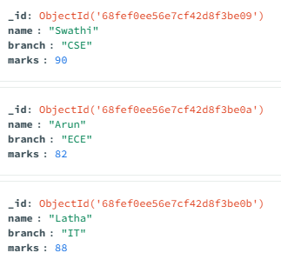
- db.students.find()
{
_id: ObjectId('68fef0ee56e7cf42d8f3be09'),
name: 'Swathi',
branch: 'CSE',
marks: 90
}
{
_id: ObjectId('68fef0ee56e7cf42d8f3be0a'),
name: 'Arun',
branch: 'ECE',
marks: 82
}
- db.students.updateOne(
{ name: "Ravi" },
{ $set: { marks: 90 } }
)
{
acknowledged: true,
insertedId: null,
matchedCount: 0,
modifiedCount: 0,
upsertedCount: 0
}
- db.students.deleteOne({ name: "Ravi" })
{
acknowledged: true,
deletedCount: 0
}

